Name: jobin t j
Roll No:7
Batch:mca - B
Date:9/5/2022

NETWORKING & SYSTEM ADMINISTRATION LAB

Experiment No.: 1

Aim
write a shell script to display current date and calendar

Procedure
echo "Today is $(date)"
echo ""

echo "Calendar :"
cal

Output Screenshot
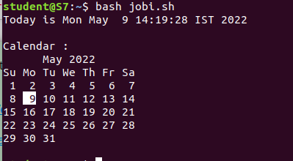

Experiment:2

Aim
write a shell script to check the number is greater than,less than,equalto another number

Procedure
echo "enter a first number1 "
read number1
echo "enter a second number2"
read number2

if [ $number1 -eq $number2 ]
then
echo "$number1 -eq $number2 : a is equal to b"
else
echo "$number1 -eq $number2: a is not equal to b"
fi

if [ $number1 -ne $number2 ]
then
echo "$number1 -ne $number2: a is not equal to b"
else
echo "$number1 -ne $number2 : a is equal to b"
fi

if [ $number1 -gt $number2 ]
then
echo "$number1 -gt $number2: a is greater than b"
else
echo "$number1 -gt $number2: a is not greater than b"
fi

if [ $number1 -lt $number2 ]
then
echo "$number1 -lt $number2: a is less than b"
else
echo "$number1 -lt $number2: a is not less than b"
fi

if [ $number1 -ge $number2 ]
then
echo "$number1 -ge $number2: a is greater or equal to b"
else
echo "$number1 -ge $number2: a is not greater or equal to b"
fi

if [ $number1 -le $number2 ]
then
echo "$number1 -le $number2: a is less or equal to b"
else
echo "$number1 -le $number2: a is not less or equal to b"
fi

Output Screenshot

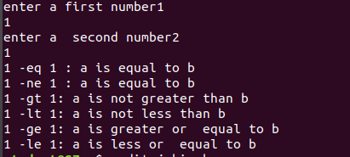

Experiment No.: 3
Aim
sum of first 10 numbers in shell script

Procedure
echo "Enter Size(N)"
read N

i=1
sum=0

echo "Enter Numbers"
while [ $i -le $N ]
do
read num
sum=$((sum + num))
i=$((i + 1))
done

echo $sum

Output Screenshot

Experiment No.: 4

Aim
write sum of average product of 4 number shell script

Procedure
echo "enter four integers"
read a b c d
sum=$(echo "$a + $b + $c + $d" | bc -l)
average=$(echo "$sum / 4" | bc -l)
product=$(echo "$a * $b * $c * $d" | bc -l)
echo "sum = $sum"
echo "Average = $average"
echo "Product = $product"

Output Screenshot
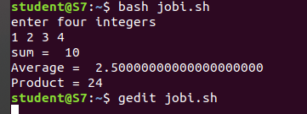

Experiment No.: 5
Aim
write a shell script to find a factorial of a number

Procedure
echo "Enter a number"
read num

fact=1

while [ $num -gt 1 ]
do
fact=$((fact * num)) #fact = fact * num
num=$((num - 1)) #num = num - 1
done

echo $fact

Output Screenshot
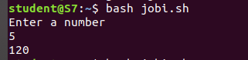

Experiment No.: 6

Aim
find palindrome number in shell script
Procedure
echo "Enter the number"
read n
function pal
{
number=$n
reverse=0
while [ $n -gt 0 ]
do
a=`expr $n % 10 `
n=`expr $n / 10 `
reverse=`expr $reverse \* 10 + $a`
done
echo $reverse
if [ $number -eq $reverse ]
then
echo "Number is palindrome"
else
echo "Number is not palindrome"
fi
}
r=`pal $n`
echo "$r"

Output Screenshot
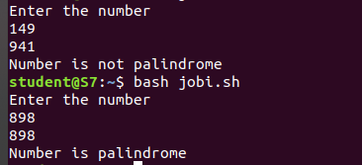

Experiment No.: 7

Aim
find leap year in shell script
Procedure
clear
echo "LEAP YEAR SHELL SCRIPT"
echo -n "Enter a year:"
read year_checker
if [ `expr $year_checker % 4` -eq 0 ]
then
echo "$year_checker is a leap year"
else
echo "$year_checker is not a leap year"
fi

Output Screenshot
